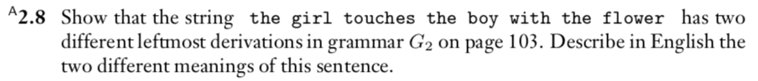

Using leftmost derivative

The girl touches the boy with flower.

1.
(statement) -> (noun)(verb)

The girl (noun)(verb)
The girl touches the boy with flower

2.
(statement) -> (noun)(verb)
-> (article)(noun)(verb)

The girl touches(article)(noun)(verb)
The girl touches the boy with flower

